**Task-06 Screenshots**

**Q1.Person called name & age-Output**

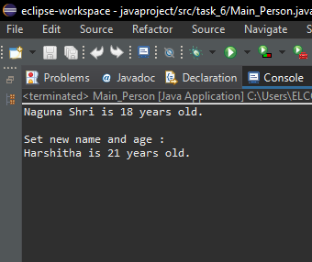

**Q2.Employee Details-Output**

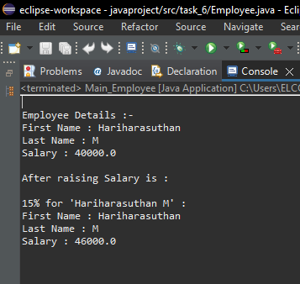

**Q3.Circle class-Output**

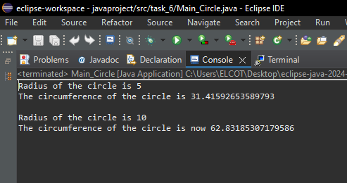

**Q4.Account Process-Output**

